Are pasta straws the new paper straws?

By: Samantha Bansi

It is common knowledge that plastic straws have caused havoc for the environment both on land and water. Could it be that their widely accepted replacement, namely paper straws, are not as environmentally friendly or biodegradable as we have been led to believe? Or for that matter a better alternative to plastic straws.

The general view on paper straws is one can still enjoy one's drink while not creating extra waste as they can be easily recycled and are biodegradable. However, this could not be farther from the truth. Paper straws in most cases are too thick to be recycled and a majority are food contaminated so therefore not accepted by recycling plants thus creating additional waste. Most paper straws contain an inner plastic lining thereby further limiting their ability to be biodegradable. Also to manufacture paper straws, poly- and perfluoroalkyl substances(PFAS) are utilized which are known to have long-term effects on the environment, people and wildlife. Additionally, in terms of functionality, paper straws are known to change the flavour of the beverage because they disintegrate quickly.

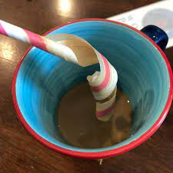

The simple solution would be to just stop producing straws and drink directly from the glass but alas we know that is not feasible. So what can be done to satisfy both the needs of the consumers while trying to be as environmentally sustainable as possible? Could the solution be something as simple as PASTA? While the idea of pasta may seem odd at first, it could be the solution to the problem.

With just two main ingredients, wheat and water, pasta straws are an exceptional alternative to paper and plastic straws. They create much less processing output thereby creating a smaller environmental impact. They are edible as well as biodegradable and require the least amount of ingredients to manufacture out of all the single-use straws. They also do not disintegrate or change the flavour of the beverage.

When plastic/paper straws end up in the world’s oceans they are often mistaken as food by marine life. If consumed, they can either cause injuries and even death or they will leach microplastics into the water and pollute it. With pasta straws in the case they end up in the ocean they will degrade or be consumed by marine life and not harm them or the water.

Restaurants, bars and many food institutions mainly across Italy have been using pasta straws instead of their counterparts as an environmentally friendly alternative for a while now. Hopefully, Italian bars implementing pasta straws into their business as well as the heightened awareness of the environmental impact of straws will be the catalyst for change.

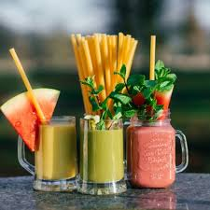

The potential for pasta straws and other alternatives to take over the industry is limitless. The pasta straw could be a relatively new and innovative way to try and combat the plastic crisis globally. There are already new alternatives popping up on the market regularly. Some of these include coconut straws, bamboo straws, and papaya leaf straws which are all significantly better than paper and plastic straws.

There are already companies seizing on the opportunity to produce pasta straws. The innovation of using pasta as straws could potentially go even further and potentially stop the use of bars supplying single-use plastic straws. With time and awareness, Pasta innovations could be the reason for the downfall of plastic and paper straws. With all of this being said, there are some limitations to pasta straws that need to be mitigated. For example, due to their rigid structure, they are not feasible for people who require the bending motion of regular straws to allow them to drink without any spillage. The second drawback to pasta straws is that people who can not consume gluten can not use pasta straws or they run the risk of getting sick. These two factors will need to be adapted to if pasta straws want to make a gateway into the global market.

Sutcliffe, T. (2018, April 13). *Straws - 10 alternatives to plastic straws*. <https://www.diffordsguide.com/encyclopedia/1405/cocktails/straws-10-alternatives-to-plastic-straws>

Agumba DO, Pham DH, Kim J. Ultrastrong, Hydrostable, and Degradable Straws Derived from Microplastic-Free Thermoset Films for Sustainable Development. ACS Omega. 2023 Feb 16;8(8):7968-7977. doi: 10.1021/acsomega.2c07797. PMID: 36873009; PMCID: PMC9979226.